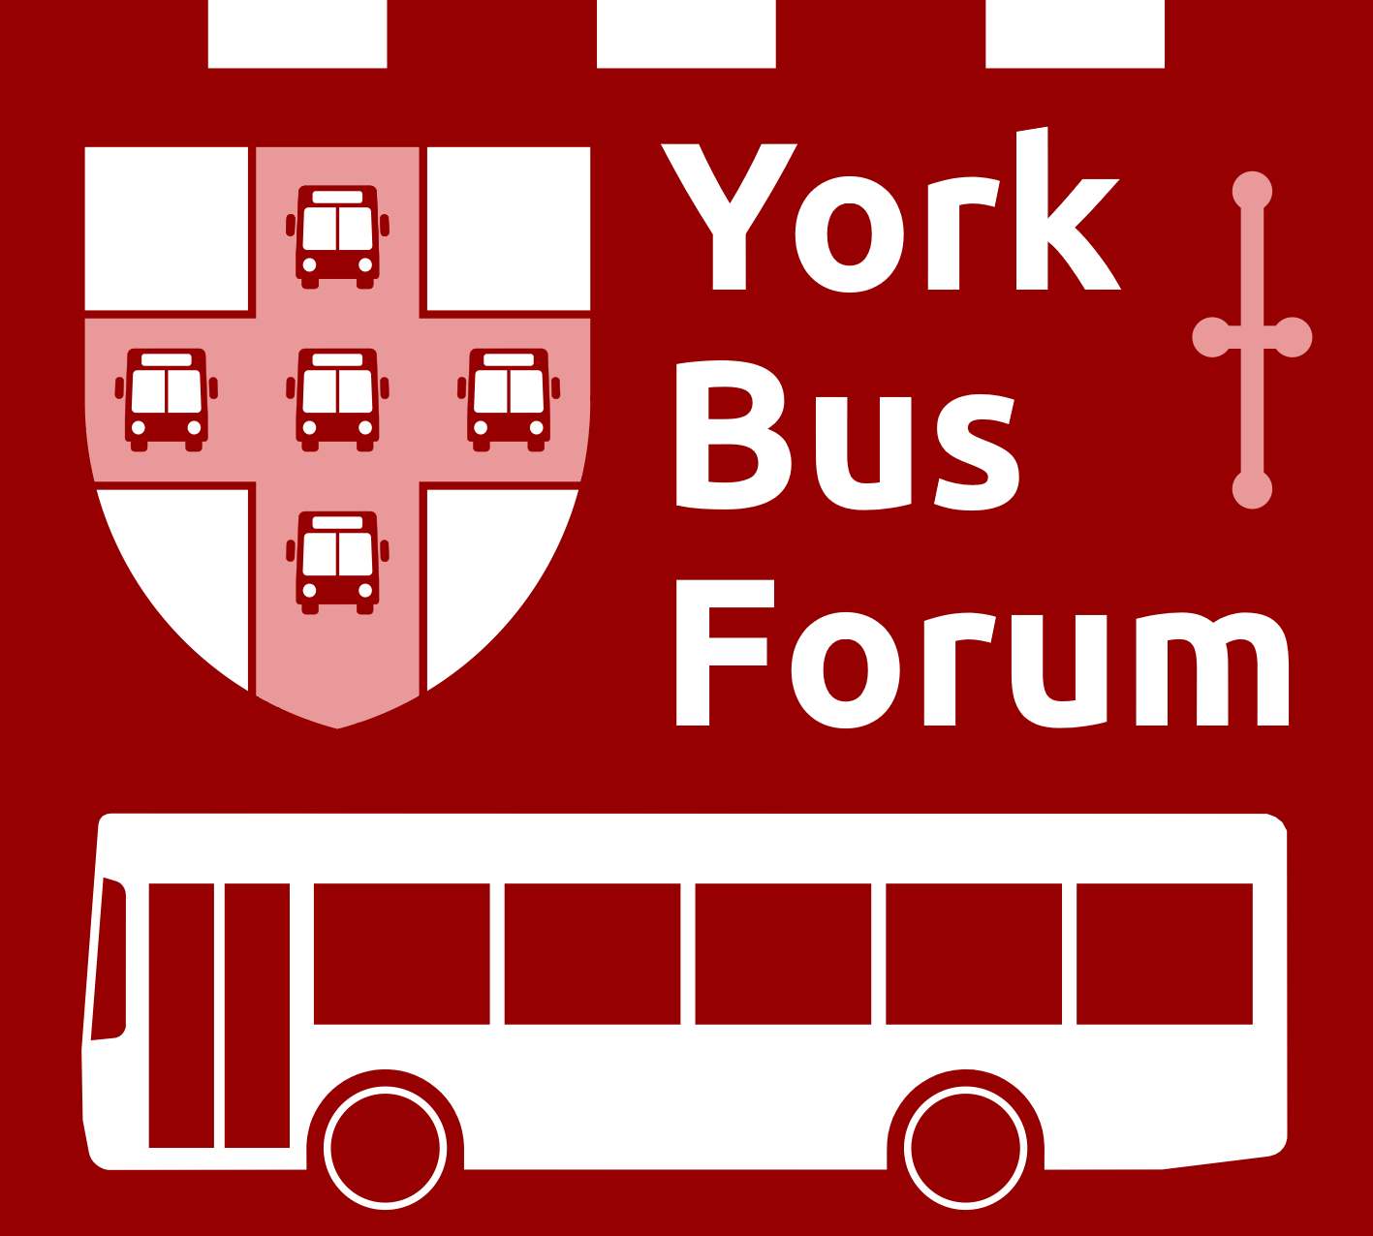
York’s Voice for Bus Users
https://www.yorkbusforum.org

NEWS RELEASE – York Bus Forum supports call for a full Local Transport Plan
York’s bus services should be on the brink of big improvements thanks to government grants for network enhancements and more electric buses, but there appears to be a shortage of a plan to ensure that the money produces the outcomes necessary to meet future needs. The latest Local Transport Plan (2011) is obsolete and was never fully implemented anyway. York Civic Trust has published a “Call to Action” which requests urgent attention to the important issues of how we will get around our increasingly overcrowded city.
The City of York Council has now produced a new Local Transport Strategy and is launching a new consultation process. This is warmly welcomed by the York Bus Forum, but again we would like greater detail on the measures to be introduced and the results of these actions!
Despite being awarded the funding to make substantial improvements, we still haven’t seen any details of how to encourage more use of Park and Ride, how extending bus lanes can improve timekeeping, or how people can be encouraged to use buses more and cars less.
All this new funding (over £25 million) could be wasted without an all-encompassing transport plan. New electric buses are most welcome but can't deliver their benefits if they are stuck in traffic jams. Passengers won’t use the services if they don’t run frequently and reliably and they aren’t given accurate up-to-date information. Many of York’s bus stops lack a shelter to provide some protection for the weather and seating for passengers, there are no details in the current documents of how and when these will be provided.
Doreen Magill, Chair of the York Bus Forum said, “It is surprising that no detailed plan is available with so much at stake, we look forwards to working with all parties to see the improvements to our bus service that the city deserves”.
York’s population is expected to increase by 40,000 in the next 10 years and visitor numbers are returning. Both universities are growing, and it is hoped that Government jobs will be relocated here. The extra strain this will put on road capacity can only be handled by better bus services. The Council have in their strategy document suggested that we need to increase bus passenger numbers by 50%, but have not identified the ways in which this will be achieved in their draft Strategy.
A plan presenting workable options for the future demonstrating the way in which increased bus use will be achieved, and hence contribute to delivering pollution, congestion and carbon emissions reductions is needed NOW!
More information is available at https://www.yorkbusforum.org/or contact Graham Collett at vicechair@yorkbusforum.org or Niall McFerran at secretary@yorkbusforum.org
Note to Editors.
York Bus Forum is 7 years old and provides a means by which bus users can meet and discuss issues with representatives of the bus operators, City of York Councillors and the Council Transport Team. It has over 50 members and several affiliated Parish Councils, usually meets monthly and is now a recognised stakeholder in the city’s Enhanced Partnership for buses.
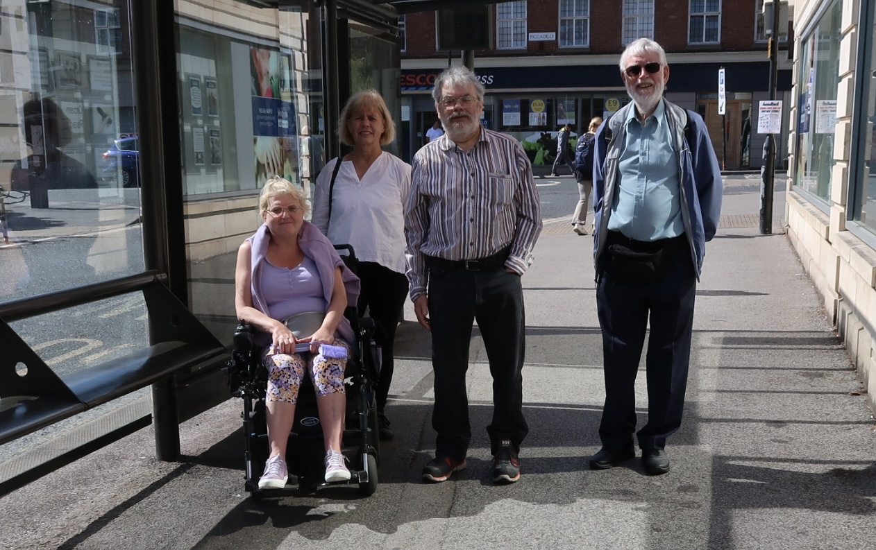

Caption: Flick Williams, Doreen Magill, Alan Robinson and Graham Collett of York Bus Forum.

